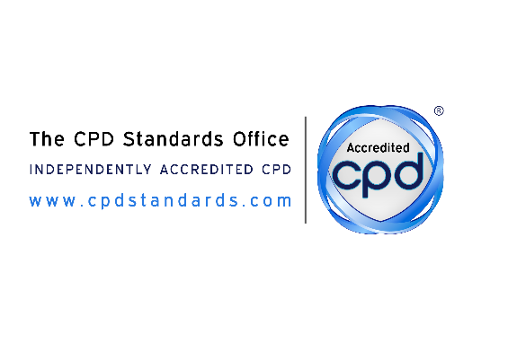

WEBSITE LISTING INFORMATION

Please return this via email to : anirudh.narendran@cpdstandards.com

Company name: | Elite Injury Care
Company website: | http://eliteinjurycare.net
CPD Standards Office Provider ID: | 21554

Please provide a brief description of your organisation here:  - Please include: your organisation name, sector, and a description of your main service/offer  - Please also consider including: organisations age, specific merits, its unique qualities  Note: This is for your listing on our website and therefore the tone must be descriptive and describe the services that could be offered to potential clients  Please ensure the text is written in the present tense unless referring to the business history.  This description should not exceed 100 words | Elite Injury Care  Health care professionals  Provide training and education to healthcare professionals eg. Physiotherapists, Chiropractors, Sports therapist, Masseuses Personal Trainers etc. The students will learn how to apply kinesiology tape and Instrument Assisted Soft Tissues Mobilisation with the tool to different areas of the body and Rehab techniques.

Accredited Courses/Events/Online  Mobile Activities/Coach  Please list all accredited activities that you wish to be included in your web listing under the relevant headings here: | Sports Kinesiology Taping  Instrument Assisted Soft Tissues Mobilisation with massage tool.
Who should attend the CPD Training Course/Activity/Event/Coaching  Please explain who the activity is for. If a course/activity has a very specific target group please make this clear.  If the delegate group is more generic please outline which sectors it is applicable to. Please keep text to a minimum of 2 sentences to explain to delegates what the course/event/activity/coaching involves/includes. | Physiotherapists  Chiropractors  Personal Trainers  Sports Therapists  Masseuses  Physical Therapist

ACCREDITED ACTIVITY CATEGORY

PLEASE CIRCULATE/HIGHLIGHT IN WHICH CATEGORY YOUR ACCREDITED ACTIVITY SHOULD BE PLACED (this may be more than one/several)

Accountancy | Administration & PA services | Alternative Practices | Beauty | Business Development
Business Professionals | Charity/not for profit | Child Centred | Coaching | Communication/  Presentation
Construction | Customer Services | Dentistry | Digital Marketing | Education
Energy | Engineering | Finance | Government | Governance/  Compliance
Healthcare | Health & Safety | HR | Leadership and Management | Legal
Logistics | Management | Marketing | Medical | NLP
Oil & Gas Industry | Personal Development | Procurement | Psychological Skills | Sales
Science | Social and Care work | Transport and Vehicles
Other:
Please explain

PLEASE UPLOAD YOUR HIGH RESOLUTION COMPANY LOGO HERE (preferable ratio 3:2):

Thank you
CPD Standards Office

